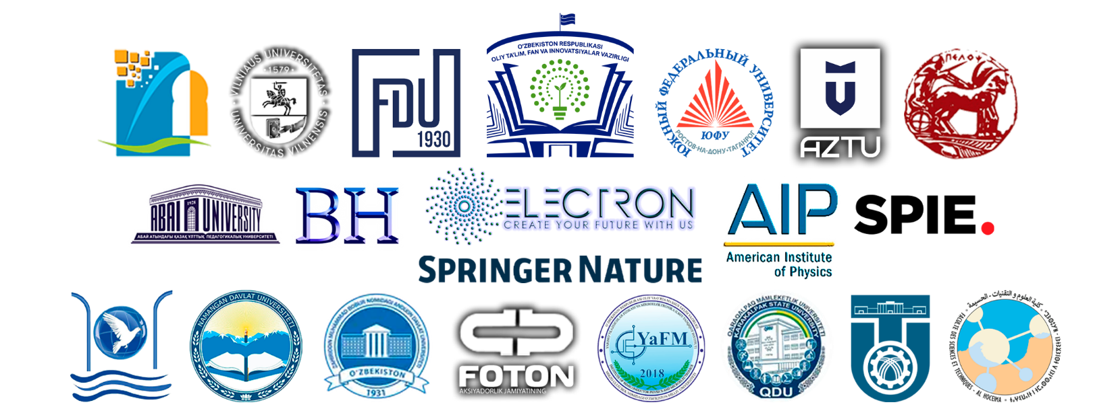

INFORMATION LETTER

In accordance with the Order of the Ministry of Higher Education, Science and Innovation of the Republic of Uzbekistan No. 11 dated January 16, 2026, the Ministry of Higher Education, Science and Innovation of the Republic of Uzbekistan, Ferghana State University, Vilnius University of Lithuania, Southern Federal University of Rostov-on-Don, Sultan Mulai Sliman Beni Mellal University (USMS) Morocco, Abdelmalek Essaâdi University in Morocco, Al-Hussein Faculty of Science and Technology, Abdulmalik Al-Saadi University in Morocco, Azerbaijan Technical University of Baku, Peloponnesian University of Greece, Kazakh National Pedagogical University named after Abai, Osh Technological University named after Academician M. M. Adisheva, Berdak Karakalpak State University, AIP Conference Proceeding, Proceedings of SPIE – The International Society for Optical Engineering, Springer Proceedings in Physics, Lecture Notes in Networks and Systems, Scientific Research Institute "Physics of Resonant Nuclear Reactions" at Electron Laboratory LLC, Electron Laboratory LLC, International Scientific Journal "All Sciences", Scientific Research Institute "Physics of Semiconductors and Microelectronics" at the National University of Uzbekistan, Andijan State University, Namangan State University, On May 7-8, 2026, PHOTON and BMX will hold the I International Scientific and Practical Conference "Formation of scientific and practical directions of digital and sustainable development based on the integration of nanomaterials, robotics, information technologies and innovative pedagogy in the process of modernization of technological education" (NRTP-I-2026).
The purpose of the conference is to combine scientific and applied research in the field of technological education, expand the possibilities of integrating modern technologies into the educational process, develop new pedagogical solutions and create a solid platform for large-scale international scientific cooperation. This event is aimed at harmonizing the national education system in connection with global trends in technological education, introducing advanced innovative developments into the educational process, expanding and presenting the latest achievements in the field of scientific progress, ensuring close interaction between global research teams, strengthening interdisciplinary integration and creating a platform for the exchange of experience between young researchers.
We kindly ask you to send your reports, abstracts and scientific articles in Uzbek, Russian or English by e-mail to the conference section coordinators by April 25, 2026. The file name of the submitted reports and abstracts should include the section number. Abstracts that do not meet the requirements and do not contain scientific and practical recommendations will not be presented in the conference proceedings.

Abstracts of reports on the following relevant areas are accepted for publication:

Section number | Section direction | Email and contacts of the coordinators
1 – section | The essence and importance of improving technology teaching in the new era of Uzbekistan's development | +998913982397  gulasal_x@mail.ru
2 – section | Theory and technology of nanostructures in materials science and technology education | +998936431433  otajonov_s@mail.ru
3 – section | Conceptual problems and solutions of teaching automation and robotics in technology education | +998972871991  neo_gizmo1@mail.ru
4 – section | The importance of integrated modern information technologies in teaching subjects in the field of technological education | +998939741023  boqirov_j@mail.ru
5 – section | Prospects of using innovative pedagogical and digital technologies in the transformation of technological science | +998972088068  +998930418558  barchin.askarova@mail.ru
6 – section | Efficient management of facilities using non-traditional energy sources using artificial intelligence | +998939710263  rova08@mail.ru

The requirements for the abstracts of the submitted reports are given in Appendix 1-2.
The essence of the conference is the active development of scientific and methodological proposals for improving teaching techniques, discussing advanced research in the field of materials science and nanostructures, their full adaptation to the educational and technological process, analyzing problems arising from the automation of learning, using the principles of robotics, as well as offering effective solutions in this area. Scientific and practical recommendations will also be developed to strengthen the role of modern information and communication technologies in technological education, expand the capabilities of the digital education system and the information and pedagogical approach. An important focus of the event is the presentation of scientific developments related to non-traditional energy sources, the identification of mechanisms for integrating their theory, practical application and a complete training program in the direction of these energy sources in the education system. At the same time, the main objectives of the conference include the development of international scientific cooperation and the creation of opportunities for the implementation of new joint projects.
Based on the information received and the results achieved, methodological recommendations and proposals will be developed to improve the quality of technological education in schools and universities of our Republic in accordance with the requirements of the National Program.

The conference materials will be published in a collection and distributed to the participants in electronic form. At the same time, the authors of abstracts and scientific articles are responsible for the information they provide. The authors who actively participated in the conference will receive a special Certificate of participation.
The theses and scientific articles recognized as the best will be considered worthy of publication in the following journals included in the Scopus databases: AIP Conference Proceeding, Proceedings of SPIE – The International Society for Optical Engineering, Springer Proceedings in Physics, Lecture Notes in Networks and Systems, as well as other additional journals included in the publisher's database Springer Nature and AIP Proceedings, globally included in the Scopus database. The conference administration will contact the authors with a proposal to send the article for subsequent publication and negotiations in Scopus.
Also, most of the articles recognized as worthy will be published in the International Scientific Journal "All Sciences" of the Research Institute of Physics of Resonant Nuclear Reactions in accordance with its requirements. All authors of worthy abstracts and scientific articles that have been reviewed will receive an Author's Certificate confirming publication in the International Scientific Journal All Sciences of the Research Institute of Physics of Resonant Nuclear Reactions.
Sending and publishing abstracts, scientific articles, participation in the conference is absolutely free!
The online form of the conference will be held on May 7-8, 2026 at 9:00 a.m. on the Zoom platform. A link to the Zoom conference will be sent to the email address provided by the participants during registration.

Appendix 1
Requirements for submitted materials
Requirements for the preparation of abstracts:
General requirements. Abstracts are prepared in doc, docx format. The volume of abstracts should not exceed 5 pages. Margins: left – 3 cm, right – 1.5 cm, top – 2 cm, bottom – 2 cm. Document font: Times New Roman, 14 size, regular. Line spacing: 1.5, without additional spacing before and after paragraphs. Paragraph: 1.25 cm.
Requirements for the title. The title should be written in capital letters. Alignment: centered.
Requirements for specifying the authors. Full name must be indicated in full italics, indicating the upper indexes. Alignment: centered. After specifying the authors, the full names of the organizations and addresses should be present on the next line, indicating the number.
Alignment of the main text: in width.
Requirements for illustrations and graphs. They must be presented in a file with a resolution of at least 150 dpi. The signatures of graphs, tables, and illustrations should be numbered. Alignment of captions of graphs and figures: in the center. Table captions are aligned to the right. The rest of the signature parameters are executed in a standard font, according to the general requirements.
Requirements for formulas. Formulas must be executed in Microsoft Equation in the built-in Microsoft Office Word or MathType plugin with mandatory numbering.

Requirements for the design of scientific articles for reports:
General requirements. Scientific articles are formatted in doc, docx format. The volume of abstracts should not exceed 30 pages. Margins: left – 3 cm, right – 1.5 cm, top – 2 cm, bottom – 2 cm. Document font: Times New Roman, 12 sizes, regular. Line spacing: 1, without additional spacing before and after paragraphs. Paragraph: 1.25 cm.
Requirements for the title. The title should be written in capital letters (bold). Alignment: centered.
Requirements for specifying the authors. Full name must be indicated in full italics, indicating the upper indexes. Alignment: centered. After specifying the authors, the full names of the organizations and addresses should be present on the next line, indicating the number.
Alignment of the main text: in width.
Requirements for illustrations and graphs. They must be presented in a file with a resolution of at least 150 dpi. The signatures of graphs, tables, and illustrations should be numbered. Alignment of captions of graphs and figures: in the center. Table captions are aligned to the right. The rest of the signature parameters are executed in a standard font, according to the general requirements.
Requirements for formulas. Formulas must be executed in Microsoft Equation in the built-in Microsoft Office Word or MathType plugin with mandatory numbering.
At the end of abstracts and scientific articles, please indicate the contact details of the authors, as well as underline the authors who wish to speak at the conference online or offline. Abstracts and scientific articles of reports should contain original results that have not been published before.

Appendix 2
Additional requirements for theses
International Scientific Conference
"Formation of scientific and practical directions of digital and sustainable development based on the integration of nanomaterials, robotics, information technologies and innovative pedagogy in the process of modernization of technological education"
REQUIREMENTS FOR CONFERENCE ABSTRACTS:
The text of the article should be written in doc. and docx. format, in Times New Roman font, 14 paragraphs, line spacing 1.15. The thesis should take up to 3 pages, A4 format (210x297 mm), with the following margin values: top edge – 20 mm; left edge – 30 mm; bottom edge – 20 mm; right edge – 15 mm.

The title of the article is written in capital letters in bold. The full name of the speakers is indicated on the new line. The following line contains the full name of the organization without abbreviations, postal code, city/region, state/region, and country of each affiliation. The title of the thesis, the names of the authors, and the full name of the organization should be centered and written in capital letters. The text of the paper follows the missing line. The text of the work itself is written with a paragraph indentation of 1 cm.
After the main text, a list of references is provided, compiled according to the following example, followed by one empty line.:

References:
(for the article)
[1] Full name. The title of the article. The name of the magazine. (year), number (or volume (number)), pp. 1-10. DOI or a link on the journal's website.
(for the book)
[1] Full name. The name of the book. (City, Publisher, Year) – number of pages.

